Session 2025-2026(EVEN)

Vision: To build innovative technology solutions that improve public safety, healthcare, and smart ecosystems, creating a positive impact on society through software and IoT. | Mission: To continuously develop strong skills in software engineering, IoT, AI, and cloud technologies, apply them to real-world problems, and deliver scalable, user-centric solutions through learning, innovation, and collaboration.

Program Educational Objectives of the program (PEO): (broad statements that describe the professional and career accomplishments)
PEO1 | Preparation | P: Preparation | Pep-CL abbreviation  pronounce as Pep-si-lL easy to recall
PEO2 | Core Competence | E: Environment (Learning Environment)
PEO3 | Breadth | P: Professionalism
PEO4 | Professionalism | C: Core Competence
PEO5 | Learning Environment | L: Breadth (Learning in diverse areas)

Program Outcomes (PO): (statements that describe what a student should be able to do and know by the end of a program)
Keywords of POs:
Engineering knowledge, Problem analysis, Design/development of solutions, Conduct Investigations of Complex Problems, Engineering Tool Usage, The Engineer and The World, Ethics, Individual and Collaborative Team work, Communication, Project Management and Finance, Life-Long Learning

PSO Keywords: Cutting edge technologies, Research

“I am an engineer, and I know how to apply engineering knowledge to investigate, analyse and design solutions to complex problems using tools for entire world following all ethics in a collaborative way with proper management skills throughout my life.” to contribute to the development of cutting-edge technologies and Research.

Integrity: I will adhere to the Laboratory Code of Conduct and ethics in its entirety.

Dhanashri Raut

Name and Signature of Student and Date
(Signature and Date in Handwritten)

Session | 2024-25 (EVEN) |  | Course Name | Mobile and Web Application for IOT Lab
Semester | 6 |  | Course Code | 23IOT1624
Roll No | 05 |  | Name of Student | Dhanashri raut
Practical Number |  | 4
Course Outcome |  | - Understand and apply basic Kotlin programming constructs including variables, control structures, functions, null safety, and object-oriented concepts for Android app development.  - Design and develop responsive user interfaces using XML layout files, ViewGroups, and widgets in Android Studio, adhering to Material Design principles.  - Implement event handling and application logic using Kotlin to capture user input, manage app state, navigate between screens, and interact with Android system components like Toasts and Dialogs  - Integrate learned concepts to develop a mini Android application that demonstrates use of ViewModel, multi-screen navigation, and proper UI/UX design for real-world problem-solving
Aim |  | Understand Android Studio environment and project structure. Tasks: Create Android project, analyze manifest, Gradle files, SDK versions, permissions
Problem Definition
Theory  (100 words) |  | 1. Android Studio Environment  Android Studio is the official Integrated Development Environment (IDE) for Android application development. It is based on IntelliJ IDEA and provides all the tools required to design, develop, test, and debug Android applications.  Key components of Android Studio:  - Code Editor – Supports Java, Kotlin, XML with auto-complete and error checking.  - Layout Editor – Visual tool for designing UI layouts using XML.  - Android Emulator – Allows testing apps on virtual Android devices.  - Gradle Build System – Manages project build, dependencies, and versions.  - SDK Manager – Downloads and manages Android SDK platforms and tools.  - Logcat – Displays runtime logs and errors.  Android Studio simplifies development by integrating coding, UI design, building, and debugging in a single environment.  2. Creating an Android Project  When a new Android project is created in Android Studio:  - A default project structure is generated.  - Required configuration files are automatically created.  - Gradle scripts handle project setup and dependency management.  The project is usually created with:  - Application name  - Package name  - Minimum SDK version  - Programming language (Java/Kotlin)  - Default activity (e.g., Empty Activity)  3. Android Project Structure  An Android project mainly consists of the following folders and files:  a) Manifests Folder  - Contains AndroidManifest.xml  - Acts as the entry point of the application  b) Java / Kotlin Folder  - Contains source code files for activities, fragments, and logic  - Organized by package name  c) res Folder  Contains application resources:  - layout/ – XML files for UI design  - drawable/ – Images and graphics  - values/ – Colors, styles, strings, themes  - mipmap/ – App launcher icons  d) Gradle Scripts  - Used for build configuration and dependency management  4. AndroidManifest.xml  The AndroidManifest.xml file provides essential information about the app to the Android system.  Functions of Manifest:  - Declares application components (activities, services, receivers)  - Specifies the main launcher activity  - Defines permissions  - Specifies minimum and target SDK versions  Important elements:  - <manifest> – Root element  - <application> – Application-level settings  - <activity> – Screens of the app  - <intent-filter> – Defines app entry points  - <uses-permission> – Declares required permissions  5. Gradle Files  Gradle is the build automation system used by Android Studio.  a) Project-level Gradle  - Defines repositories and global configurations  - Applies plugins common to all modules  b) Module-level Gradle (app-level)  - Specifies SDK versions  - Defines dependencies (libraries)  - Configures build types (debug/release)  Gradle automates tasks like compiling code, packaging APKs, and managing dependencies.  6. SDK Versions  SDK versions define compatibility of the application.  Types of SDK versions:  - compileSdkVersion – Android version used to compile the app  - minSdkVersion – Minimum Android version required to run the app  - targetSdkVersion – Android version the app is optimized for  Correct SDK selection ensures broader device compatibility and access to modern features.  7. Permissions  Permissions allow the app to access protected system features or user data.  Examples:  - Internet access  - Camera usage  - Location access  - Storage access  Permissions are declared in the AndroidManifest.xml file using:  <uses-permission android:name="android.permission.INTERNET"
Procedure and Execution  (100 Words) |  | Step 1: Create a New Android Project  - Open Android Studio.  - Click on New Project.  - Select Empty Views Activity.  - Enter the following details:  - Application Name  - Package Name  - Language: Kotlin  - Minimum SDK version  - Click Finish.  - Wait for Gradle build to complete.  Step 2: Study Android Studio Environment  - Observe the Project Window displaying folders and files.  - Identify the following components:  - Toolbar (Run, Debug)  - Code Editor  - Emulator  - Logcat  - Familiarize with navigation and file structure.  Step 3: Analyze Android Project Structure  - Open the app module.  - Observe the following directories:  - manifests – contains AndroidManifest.xml  - java/kotlin – contains activity files  - res – contains layout, drawable, values, and mipmap folders  - Gradle Scripts – contains build configuration files  Step 5: Analyze Gradle Build Files  - Open Project-level Gradle file:  - Defines plugins and repositories.  - Open Module-level Gradle file (app):  - Observe compileSdkVersion, minSdkVersion, and targetSdkVersion.  - Observe dependencies section.  - Understand how Gradle manages the build process.  Step 6: Analyze SDK Versions  - Locate SDK versions in build.gradle (Module: app).  - Note:  - compileSdk – API level used for compiling the app  - minSdk – minimum Android version supported  - targetSdk – optimized Android version  Step 7: Analyze Permissions  - Open AndroidManifest.xml.  - Observe permissions declared using:  <uses-permission android:name="android.permission.INTERNET"/>  - Understand the role of permissions in accessing system resources.  Step 8: Run the Application  - Select an Android emulator or physical device.  - Click the Run button.  - Observe the application output on the emulator.
Code:
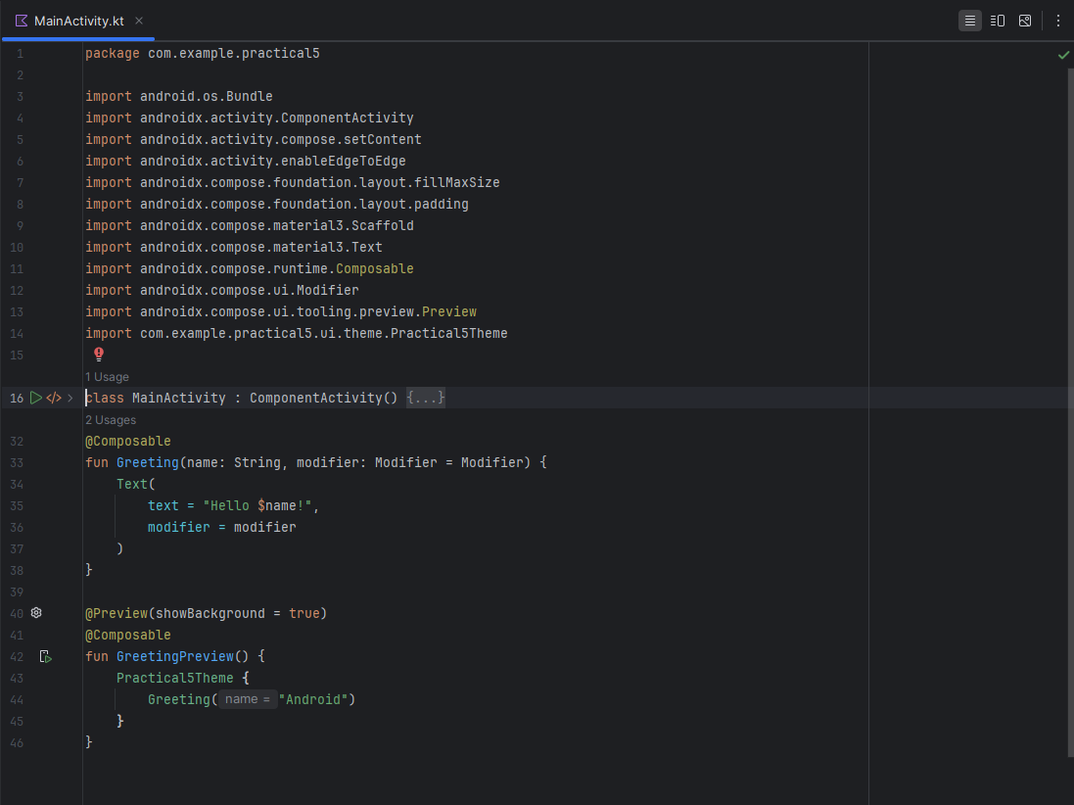
Output:

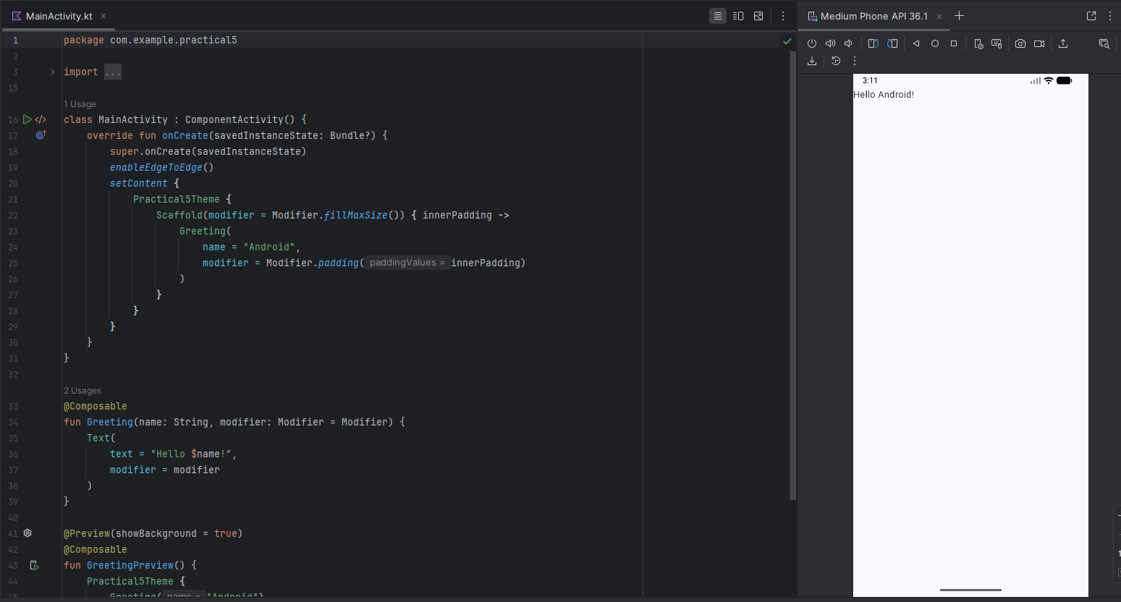

Output Analysis |  | The output confirms correct Kotlin collections and higher-order functions to process data efficiently using a functional  programming style.
Link of student Github profile where lab assignment has been uploaded |  | https://github.com/24030192-lab/PE-
Conclusion |  | In this practical, an Android application was created using Android Studio. The Android Studio environment and project structure were analyzed in detail. The importance of the AndroidManifest.xml, Gradle build system, SDK versions, and permissions was understood. This practical provides a strong foundation for developing and managing Android applications efficiently.
Plag Report (Similarity index < 12%) |  | 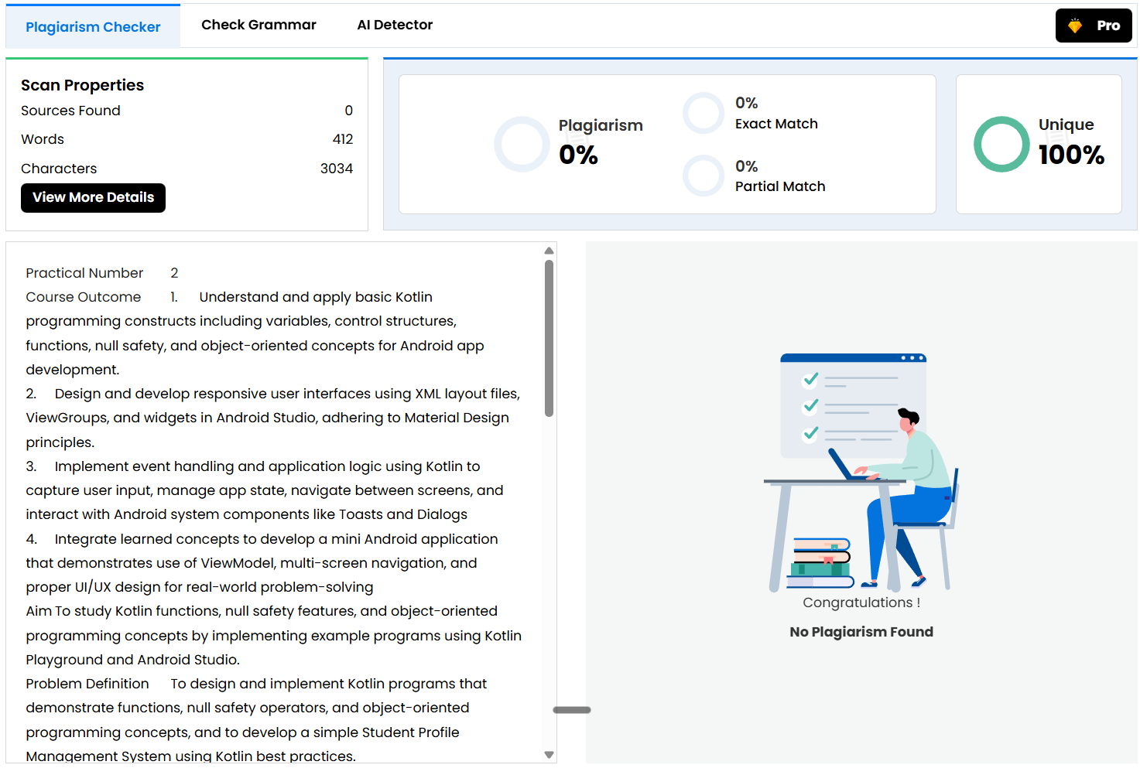
Date |  | 06/02/2026

